[Array 15 (2022) 100223](https://doi.org/10.1016/j.array.2022.100223)

|  |  |  |
| --- | --- | --- |
|  |  |  |
|  | Contents lists available at ScienceDirect |  |
| Array |
| journal homepage: [www.sciencedirect.com/journal/array](https://www.sciencedirect.com/journal/array) |

Novel group handover mechanism for Cooperative and Coordinated Mobile Femtocells technology in railway environment   
Rand Raheem*, Aboubaker Lasebae, Ali Raheem   
*Faculty of Science & Technology, Middlesex University, London, United Kingdom*

|  |  |
| --- | --- |
| A R T I C L E I N F O | A B S T R A C T |
| *Keywords:*  High-speed trains  Mobile femto  Donor eNB  Group handover  Signalling  Mobility management  Performance analysis  Railways environment | Recently, the Mobile Femto (MF) Technology has been debated in many research papers to be a promising so-lution that will dominate future networks. This small cell technology plays a major role in supporting and maintaining network connectivity, enhancing the communication service as well as user experience for pas-sengers in High-Speed Trains (HSTs) environments. Within the railway environment, there are many MF Technologies placed on HSTs to enhance the train passengers’ internet experience. Those users are more affected by the high penetration loss, path loss, dropped signals, and the unnecessary number of Handovers (HOs). Therefore, it is more appropriate to serve those mobile users by the in-train femtocell technology than being connected to the outside Access Points (APs) or Base Stations (BSs). Hence, having a series of MFs (called Cooperative and Coordinated MFs -CCMF) installed inside the train carriages has been seen to be a promising solution for train environments and future networks. The CCMF Technologies establish Backhaul (BH) links with the serving mother BS (DeNB). However, one of the main drawbacks in such an environment is the frequent and unnecessary number of HO procedures for the MFs and train passengers. Thus, this paper proposes an efficient Group HO mechanism that will improve signal connection and mitigate the impact of a signal outage when train carriages move from one serving cell to another. Unlike most work that uses Fixed Femtocell (FF) architecture, this work uses MF architecture. The achieved results via Matlab simulator show that the proposed HO scheme has achieved less outage probability of 0.055 when the distance between the MF and mobile users is less than 10 m compared to the signal outage probability of the conventional HO scheme. More results have shown that the dropping calls probability has been reduced when mobile users are connected to the MF compared to the direct transmission from the eNB. That is in turn has have improved the call duration of mobile UEs and reduced the dropping calls probability for mobile users who are connected to the MF compared to eNB direct connection UEs. |

**1. Introduction**

Being connected to wireless broadband services has risen signifi-cantly with the high deployment of smartphones, tablets, and other mobile devices. Passengers on public transportation such as buses, trams, and trains make intensive use of these devices and they require to be connected to the internet from anywhere and at any time with any-thing. Studies have shown that mobile broadband users are growing 10% annually and it was 120 million in 2019. On the other hand, forecasts have shown that smartphone users will reach 7.4 billion in 2025 which is 83% of all mobile subscriptions [1].

However, passengers on public transportation especially HST pas-sengers are the most who are suffering from the inadequacy of Quality of Service (QoS). There are so many reasons behind that and one of the

main reasons is the well-shielded structure with coated windows that leads to high penetration loss for in and out signals. Thus, all User Equipments (UEs) who are inside public transportation and connected to the serving eNB via the wireless links are suffering from high Vehicular Penetration Loss (VPL) and signal degradation.

Hence, HSTs are considered to be one of the vital transportation services in which they save time and effort. That is without neglecting the fact that HSTs are used all over the world such as Europe, China, and Japan with speeds exceeds 350 km/h [2]. As mentioned earlier, those well-shield carriages are more exposed to Doppler frequency shift, high VPL up to 40 dB, and low HO success rate. Therefore, many projects and studies have proven that there is a persistent need for seamless wireless connectivity and better QoS to be provided to train passengers in high-speed environments and future networks [3]. Hence,

* Corresponding author.

*E-mail addresses:* [R.H.Raheem@mdx.ac.uk](mailto:R.H.Raheem@mdx.ac.uk) (R. Raheem), [A.Lasebae@mdx.ac.uk](mailto:A.Lasebae@mdx.ac.uk) (A. Lasebae), [aliraheem@outlook.com](mailto:aliraheem@outlook.com) (A. Raheem).

|  |  |  |  |  |  |  |  |  |  |  |  |  |  |  |
| --- | --- | --- | --- | --- | --- | --- | --- | --- | --- | --- | --- | --- | --- | --- |
| <https://doi.org/10.1016/j.array.2022.100223>  [Received 22 December 2021; Accepted 3 July](https://doi.org/10.1016/j.array.2022.100223) 2022  Available online 9 July 2022  2[590-0056/Crown](http://creativecommons.org/licenses/by-nc-nd/4.0/)  [Copyright](http://creativecommons.org/licenses/by-nc-nd/4.0/) [©](http://creativecommons.org/licenses/by-nc-nd/4.0/) [2022](http://creativecommons.org/licenses/by-nc-nd/4.0/)  [Publish](http://creativecommons.org/licenses/by-nc-nd/4.0/)ed  (<http://creativecommons.org/licenses/by-nc-nd/4.0/>). | by | Elsevier | Inc. | This | is | an | open | access | article | under | the | CC | BY-NC-ND | license |

*R. Raheem et al.*  *Array 15 (2022) 100223*

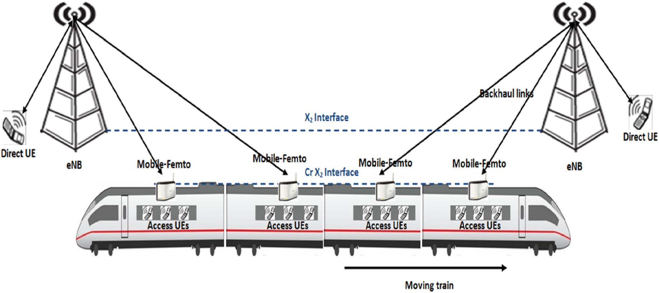

**Fig. 1.** CCMFs scenario in HST environments.

Communication Enablers for Twenty-twenty (2020) Information Society (METIS) is considered to be one of the few projects in which it has considered the deployment of small cells technology inside HST envi-ronments to improve vehicular UEs wireless connectivity.

Therefore, this paper discusses the deployment of the CCMF Tech-nologies inside the HSTs environment to improve train passengers’ signal quality and network connectivity. The CCMFs technology is seen to be a promising solution to overcome the issue of coverage in the high- speed railway environment. The CCMF technology is installed on trams, trains, and other large-spatial-dimensions vehicles. Hence Fig. 1 shows that the CCMFs themselves are connected with each other via the CrX2 coordination interface. Having such a connection allows the high opti-misation of group HO procedure and BH link connections in which both will be investigated further in this work. That is essential to maintain the data and voice services of mobile users inside the high-speed railway environment.

While the main contribution of this paper is proposing an efficient mobility management scheme in which it improves and supports seamless mobility between the DeNB and other small cells technologies. In this framework, new rules are presented to support the HO procedure and link adaptation that maintain signal strength and quality during UEs’ mobility together with the presented small cells mobility. One of these rules is the group HO procedure for all train passengers when handing over the small cell technology from one Macrocell to another. Several challenges will be considered here; the HO process, resource allocation, dropping calls probability, outage probability, and other UEs performance requirements.

**2. Literature review**

There are many studies that tackled the mobile relay HO procedure but very few studies tackled the MF HO procedure. In Ref. [5] the author has discussed the mobile relay HO issue in HSTs environment. The proposed HO scheme relies on the fact that the train travels in fixed paths. The author has shown that the proposed measurement procedure was able to shorten the HO time. However, the proposed solution is limited to the fact that is not capable to survive in crowded train stations where UEs need to quickly be attached and de-attached from the mobile relays after the users get on or get off the train. Other studies have focused on enhancing the HO performance of mobile relay by reducing the HO outage probability in HSTs environment [6]. In addition, the author in Ref. [7] has focused on minimising the HO failure and link

2

*R. Raheem et al.*  *Array 15 (2022) 100223*

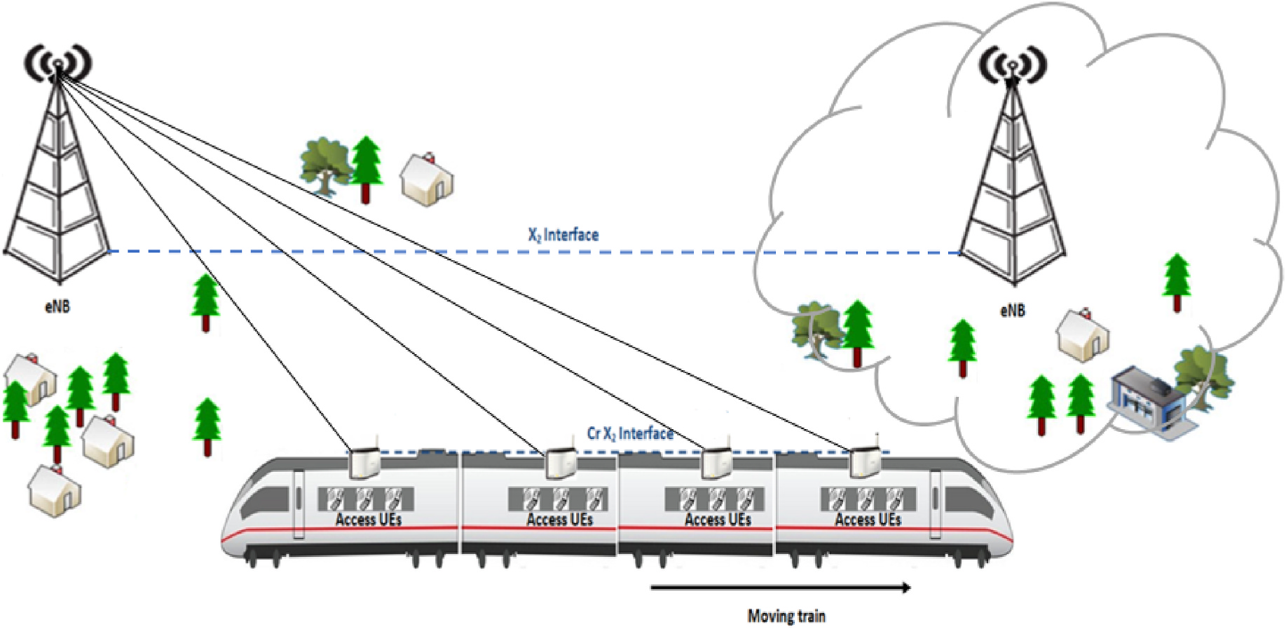

**Fig. 2.** Train movement between different coverage areas.

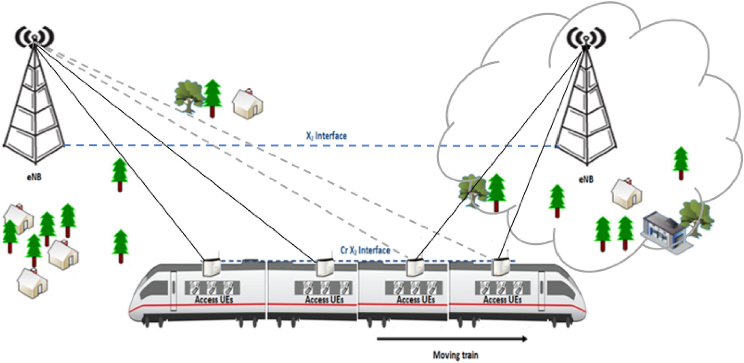

**Fig. 3.** Handing over MF from the S DeNB to the T DeNB.

cell. The proposed solution has shown a significant reduction in the signal outage probability, dropping and blocking calls probability, and improved the throughput of future networks in general. However, the previous studies were limited to the fact that the Doppler shift and speed on bus environment are completely different from the ones on the HSTs environment. The latter is more exposed to signal degradation because of the high speed of trains, which requires sufficient maintenance for UE’s signal especially when the coverage area changes rapidly in such an environment. Therefore, installing the MF in HSTs environment will be further discussed in this research paper.

In contrast, in Ref. [4] we have introduced the CCMF technology in which has improved the signal quality and UEs internet experience in-side high-speed railways environment. The achieved results have shown great improvement after deploying the CCMF technology in comparison to other technologies. The CCMFs is implemented on trains and other large-spatial-dimensions vehicles where those CCMFs are connected to

3

*R. Raheem et al.*  *Array 15 (2022) 100223*

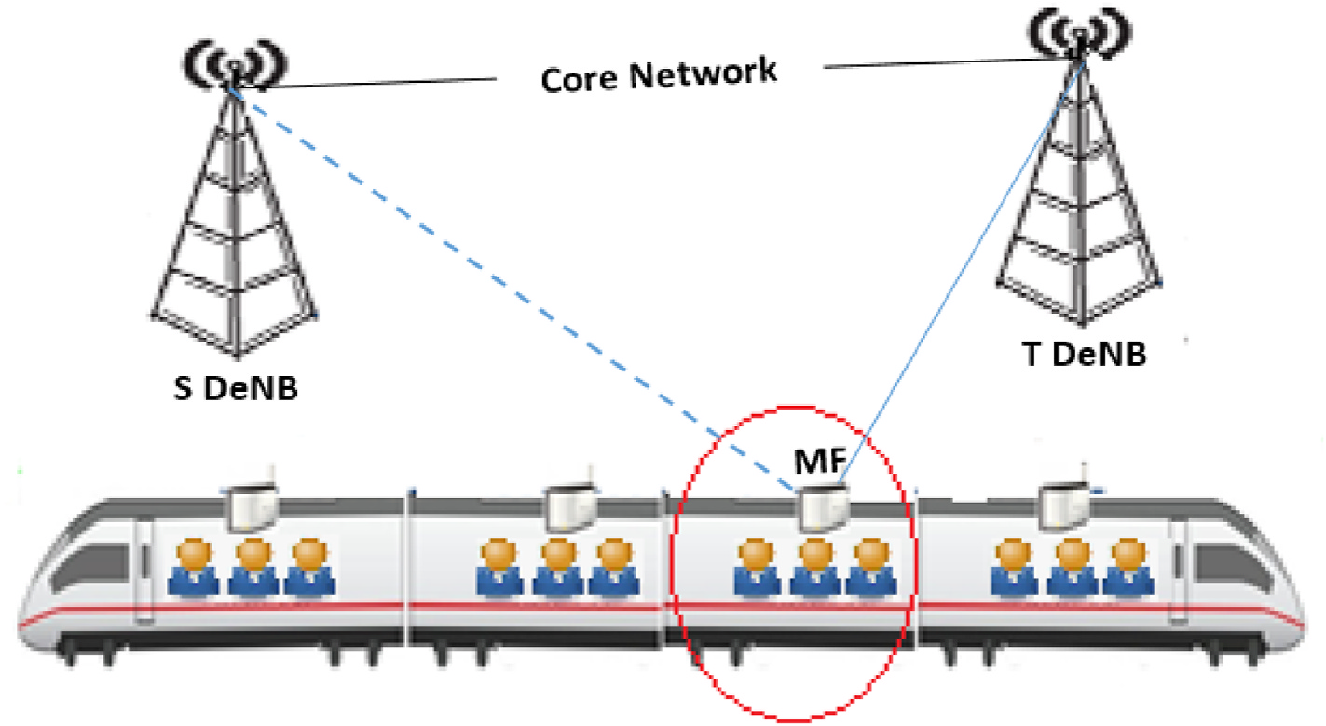

**Fig. 4.** UEs group handover.

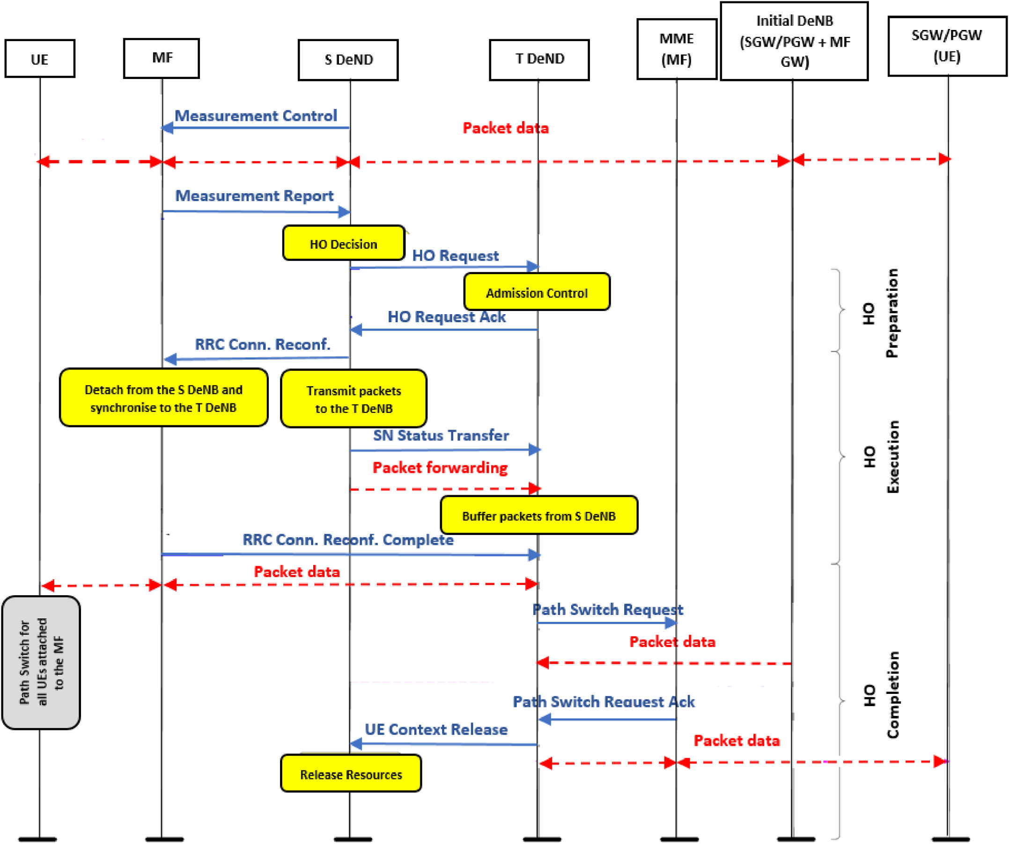

**Fig. 5.** Proposed HO mechanism for MF with its attached UEs.

4

*R. Raheem et al.*  *Array 15 (2022) 100223*

the HST environment is the most challenging issue especially with the increased demand on using such a transportation system. Thus, pas-sengers can be connected to those small cells technologies to enhance their signal quality and mitigate the number of dropped and blocked connections. However, there is another challenge with this environment which is when this small cell moves out of the coverage area of the serving eNB to another. The issue can be summarised by Fig. 2:   
 However, to solve the above issue there are a couple of possible so-lutions that can be discussed here. The first solution is by adjusting the transmission power [19]. The approach states that when the train enters the overlapped area between the serving eNB and the target eNB, the serving eNB increases its transmission power to delay the HO process. Using such an approach helps to avoid premature HOs until the train becomes closer to the target eNB. Hence, the target eNB starts increasing its transmission power while in turn, the serving eNB starts decreasing its transmission power in order to let the HO process take its place smoothly.

On the other hand, the efficient coverage planning of the base sta-tions along the railway track is an important aspect in order to improve the HO operation [20]. That can be facilitated by placing the MF on train carriages in their correct locations. Since the available transmission power of the mother BS is assumed to be 46dBm for the inter-BS spacing of 3.8 km [18], studies have proven that the required power to achieve a sufficient QoS by train passengers can exceed the 46dBm especially when the train is near the cell boundary. That is almost halfway between consecutive BSs. Thus, when the coverage planning process takes into account the presence of the MF together with the QoS requirements, this can significantly enhance the signal strength and internet connection for train passengers. That can only be done when the presented MFs are positioned in their right locations which can reduce the power con-sumption at the BS end.

Hence, the CCMF is seen to be a promising solution for the high- speed railway environments and future networks. As a result, it is required to understand the HO mechanism and call maintenance of train passengers when the train moves away from the serving eNB to the target eNB as shown in Fig. 3. Thus, main challenge of offering seamless HO in HST and future networks is data forwarding from the Serving DeNB (S DeNB) to the Target DeNB (T DeNB). As mentioned earlier, Fig. 3 illustrates the fact that when the MF leaves the coverage area of the S DeNB towards the T DeNB the HO process will take a place here to maintain the vehicular UEs’ connection who are connected to the serving the MF.

However, the HO process, in this case, will not be per UE but it will be per a group of UEs connected to the serving MF as shown in Fig. 4. The group HO procedure is established when the signal strength –Signal to Interference and Noise Ratio (SINR) between the MF and the S DeNB drops. The chosen T DeNB depends on the train path which is usually fixed in a known direction. Added to that, the success of the HO pro-cedure depends on a very important factor that cannot be neglected which is the availability of the PRB in the T DeNB. That means, in order to ensure the success of the HO procedure, the required PRB in the T DeNB must satisfy the handed-over MF with all its UEs. If that cannot be met, then the Call Admission Control (CAC) in this case allows the release of some of the BW from the existing direct links of the Macro UEs by degrading their QoS to serve the coming MF. That is because the CAC policy permits the release of the required BW for the coming MF request where in turn the system allows a maximum (*BWT DeNB* – *BWrequired*) reduction of the BW to complete the HO procedure and meet the coming MF resource demands. This HO procedure is accompanied by a group HO for all UEs inside the train carriage who are attached to the serving MF.

In contrast, it is worth mentioning if the minimum required BW at the T DeNB is inadequate even after releasing some BW from the direct links of the existing Macro UEs, then the connection of the coming MF

5

*R. Raheem et al.*  *Array 15 (2022) 100223*

their internet connection and signal quality.

Hence, the MF HO algorithm in HSTs environment has been repre-sented below:

Algorithm. 1. MF HO with UEs Group HO

|  |  |
| --- | --- |
| **1:**  **2:**  **3:**  **4:**  **5:**  **6:**  **7:**  **8:**  **9:**  **10:**  **11:**  **12:**  **13:**  **14:**  **15:**  **16:**  **17:**  **18:**  **19:**  **20:**  **21:**  **22:**  **24:**  **25:**  **26:**  **27:**  **28:** | *Detect the MF SINR*  *Request Measurement Report*  *S DeNB Initiates MF HO Request*  *T DeNB Receives MF HO Request*  *If BW available at T DeNB*≥*MF BW required then*   *Accept MF HO at the T DeNB*   *T DeNB BW total*= *T DeNB BW total*+ *MF BW required*  *Forward MF packets to the T DeNB*   *Path switch of The MF to the T DeNB*   *Group UE HO of MF served UE to the T DeNB*   *S DeNB Releases the occupied MF Resources*  *Else if BW available at T DeNB < MF BW required then*   *Reject MF HO*   *MF UEs detect the T DeNB signal*   *Initiate a HO to the T DeNB*   *T DeNB Receives UE HO Request*   *If BW available at T DeNB*≥*UE BW Required then*   *Accept UE HO at the T DeNB*   *T DeNB BW total*= *T DeNB BW total*+ *UE BW required*  *Path switch of The UE to the T DeNB*   *Else if BW available at T DeNB < UE BW required then*  *Reject UE HO*   *If UE signal degrades again then*   *Drop call*   *End*   *End*  *End* |

After the detailed illustration of the MF HO with all its attached UEs (group HO), now it is vital to study and evaluate the impact of the proposed HO scheme on served train passengers. The proposed HO procedure will be evaluated based on the occurrence of the signal outage and dropping calls probabilities in the HSTs environment.

**4. System level**

To create a clear evaluation and comparison between the achieved results, a mathematical model will be presented taking into account the transmission power of both, eNBs and MFs. Thus, there are two main transmission links here; the direct link between the eNB and the train passenger, and the access link between the MF and the train passenger. As mentioned earlier, the HST environment is more exposed to the high path-loss, VPL, fading, and weak SINR at the receiver end that is unable to support the required transmission rate of R bits per sec. Due to the

previously mentioned factors that could severely affect the received SINR, a signal outage in the system could happen which is known as outage probability. Nowadays, systems’ main concern is to reduce the outage probability and its impact by maintaining the train passengers’ signal connections. Therefore, studying the impact of the proposed HO procedure with the use of the CCMF in HSTs environment is the main target of this section. Fig. 6 illustrates the possible HO scenario of our proposed approach in which it is required to maintain train passengers’ connection inside train carriages. As it can be shown below, the common case is to have the train passengers connected to the installed MF inside the train carriages. However, when the MF leaves the coverage area of the S DeNB towards the T DeNB, some worst-case scenarios are to reject the HO if the PRBs at the T DeNB are not adequate to accommodate the coming MF with its attached mobile users. Thus, the attached mobile users to the serving MF as highlighted in Fig. 6 will have the option to be connected individually to the T DeNB to maintain their signal connec-tion and resist the outage probability that could take a place in this case.

Hence, it is essential to calculate the outage probability of the pro-posed HO mechanism and understand its impact in maintaining the signal connection of served UEs. There are two main cases here; when a successful Group HO procedure takes a place and when a rejection from the T DeNB takes a place. The outage probability of a single-hop system when there is a direct link between the T DeNB and the train passenger UE can be given by the following equation:

*Poutage DIrect* = *Preceived*(*SINRRx* ≤ *SINRthreshold DIrect*) (1)

The above case is when there is a HO rejection for the MF with all its attached UEs due to the inadequacy of the PRBs at the T DeNB. Thus, the UE will try to establish a HO connection with the T DeNB as its required BW is less than the MF required BW. The SINRRx, in this case, is the SINR at the receiver Rx, where the received power at Rx is represented by Preceived. The SINR threshold at the receiver Rx is represented by SINR-threshold_Direct which is required to support a given target rate over the direct link between the T DeNB and the vehicular UE. It is important to set an SINR threshold because it will give a clear indication of when the system will be outage. Hence, the SINR threshold of the direct trans-mission between the T DeNB and the train passenger (UE) can be calculated by the following equation as shown in our previous work [16]:

*SINRthreshold Direct* = *SINRthreshold MF* = 2*R*− 1 (2)

R is the required transmission Rate at the UE’s end and it is in bits/ sec. Likewise, the MF in the CCMF system supports the full-duplex transmission mode of the DeNB. As a result, at the Femtocell end, both the BH and the access links are supporting a given end-to-end R

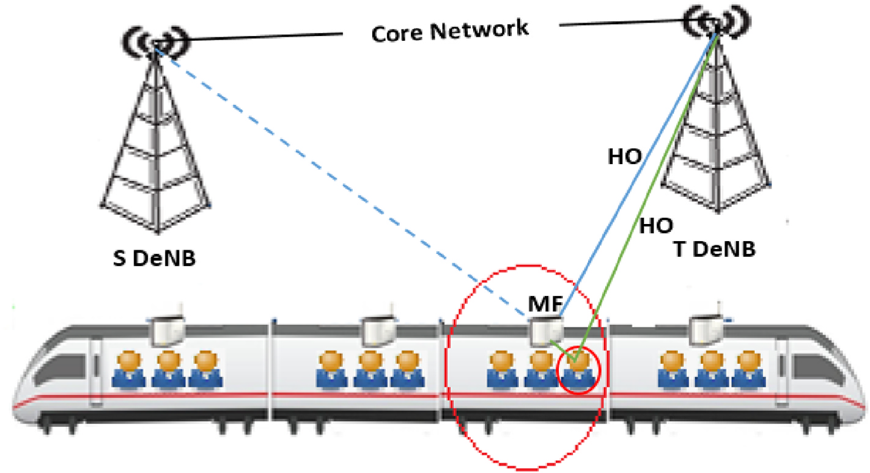

**Fig. 6.** Worst case scenario HO procedure.

6

*R. Raheem et al.*  *Array 15 (2022) 100223*

bits/sec at the receiver Rx end similar to the direct transmission from the DeNB. Hence, the same SINR threshold will be used for both cases.

The transmitter Tx has an average transmission power of Px, likewise, when the receiver Rx is at distance y from the transmitter Tx itself has a received power given by Precieved which can be calculated by [16].

|  |  |  |
| --- | --- | --- |
| *Precieved*(*y*) = *PxL*(*y*)*ψ*|*G*|2 (3)  The equation terms can be summarised by the following; L(y) is the path-loss when Rx is at distance y from Tx, whereas the power loss caused by the shadowing is given by *ψ* and G is the channel gain. Nevertheless, it is worth mentioning that both SINR thresholds of direct and access links vary according to the various QoS requirements such as the available rate R bits/sec which can be calculated via the Shannon capacity theorem as follows [16]: | | |
| *R* = *BWeff* log 2(1 + *SINR*) | (4) | |
| Here the BWeff represents the BW efficiency that is offered to the served UEs while the SINR was more appropriate to be used rather than the SNR because of the consideration of the interference aspect in this case. That is actually because of the multiple access methods in which several transmitters can send information simultaneously over a signal communication channel especially when each UE is surrounded by many options to be connected to. This gives UEs the opportunity to share a band of frequencies that can easily cause interferences. However, an interferences mitigation scheme has already been discussed in our pre-vious work [4].  Hence, since the SINR threshold of the direct and access links are equal, they both can be calculated via the following equation: | | |
| *SINRthreshold Direct* = *SINRthreshold MF* = | ( 2 *BWeff* − 1 )   *R* | (5) |

Thus, the signal is outage when either the BH link or the access link is outage. The BH link can be outage when the T DeNB is unable to accommodate the coming MF due to the inadequacy of the required BW and PRBs. On the other hand, the access link can be outage when the MF itself is not attached to any eNB. Both cases can be sum-marised by the following:

*Pout* = *Precieved* (min(*SINRbackhual, SINRaccess*) *< SINRthreshold MF*) (6)

Hence, if the outage probability value is high, then the number of dropped calls/packets is high too because of the positive correlation between the two. Dropping calls probability is a key performance indi-cator that is used by many service providers to measure the system QoS and the efficiency of the HO procedure. There are many other factors that play important role in increasing the number of dropped calls and these factors can be summarised by the VPL inside train carriages, path- loss, and shadowing. In fact, the shadowing issue is caused by the obstacle between the transmitter and the receiver where this obstacle absorbs the power. That is also known as penetration loss which is common in vehicular and indoor environments. On the other hand, the path-loss issue is caused by the dissipation of power that is radiated by the transmitter together with the effects of the propagation channel. However, the used path-loss model in our HSTs environment scenario is the Microcell non-line-of-sight (NLOS) path-loss model that is given by:

*PL*(*L*) = 34*.*53 + 38log 10(*L*) (7)

where L is the distance between the transmitter and the receiver. However, in wireless systems, there is a target minimum received level of Pmin, and whatever power below this set power threshold, the per-formance will be unacceptable. Thus, dropping calls probability can be given by:

7

*R. Raheem et al.*  *Array 15 (2022) 100223*

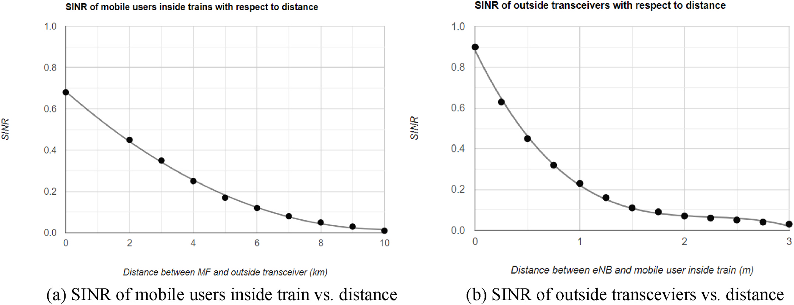

**Fig. 7.** (a) SINR of mobile users inside train vs. distance (b) SINR of outside transceviers vs. distance.

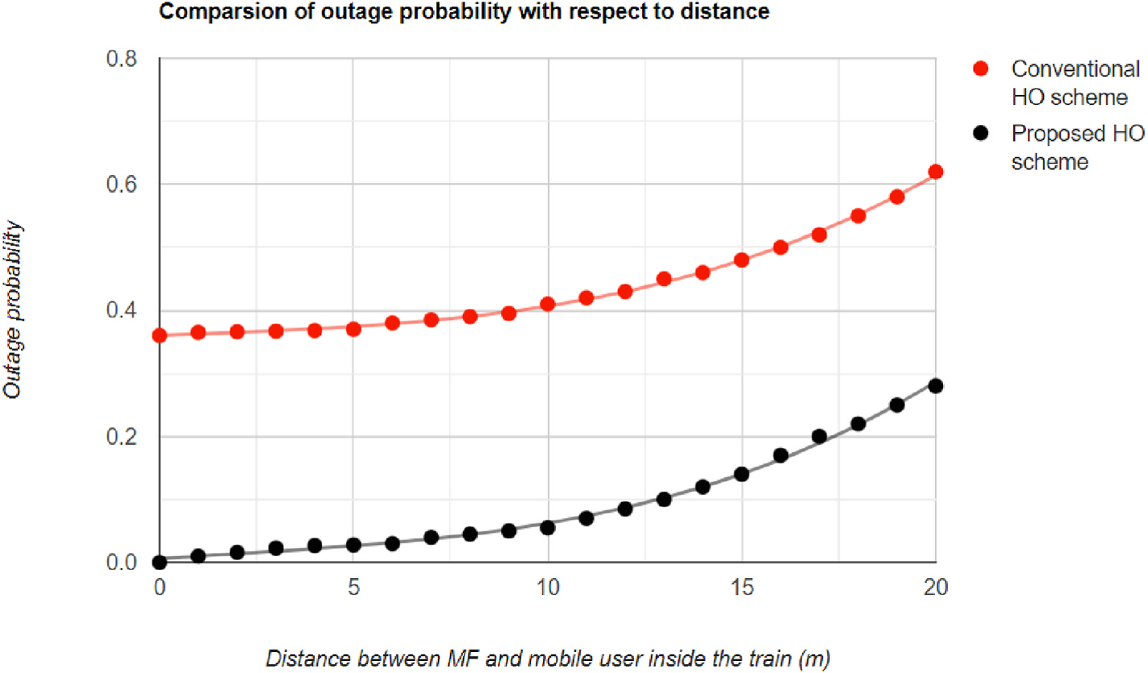

**Fig. 8.** Outage probability vs. distance.

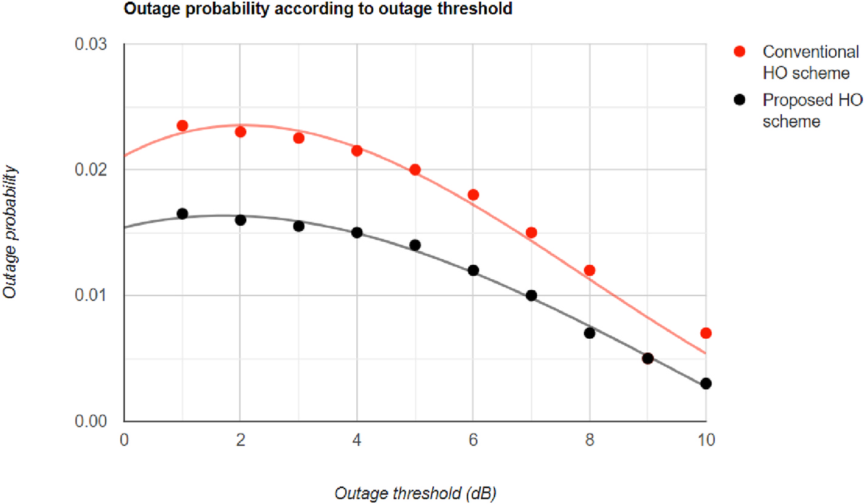

**Fig. 9.** Outage probability vs. outage threshold.

8

*R. Raheem et al.*  *Array 15 (2022) 100223*

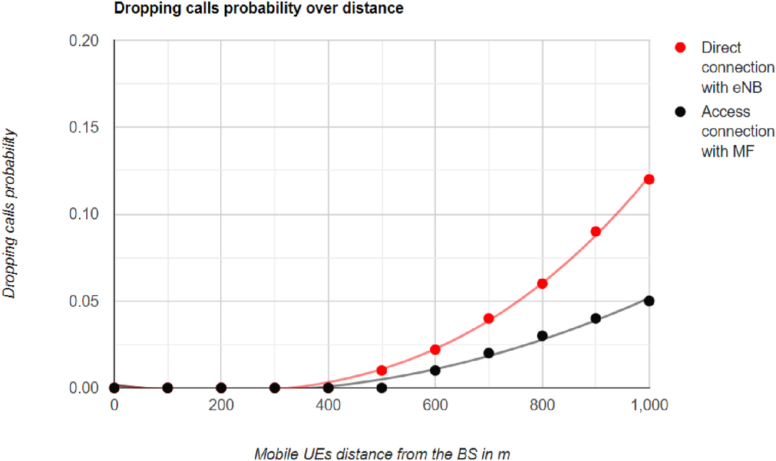

**Fig. 10.** Dropping calls probability vs. distance.

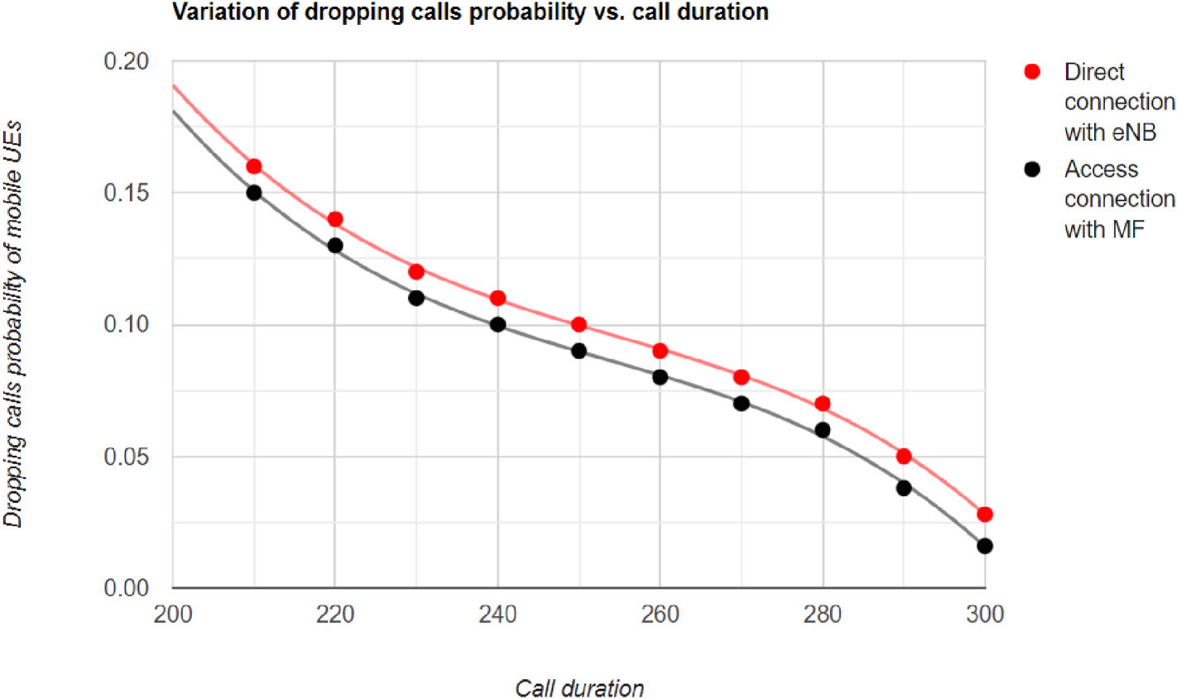

**Fig. 11.** Dropping calls probability vs. call duration.

*(Pr(d) < P*min*)*. The results show that the MF achieves less dropping probability when the distance *d* between the mobile user and the serving base station is less than 500 m. That is because of the reasonable short distance between the transmitter and the receiver which makes the (*Pr*(*d*) *> P*min). However. The dropping calls probability value increases after the 500 m until it reaches its maximum at 1000 m. That occurs because of the BH link variation when the installed MF inside the HSTs environment moves closer to the edge of the serving macrocell. As a result, the proposed HO scheme takes a place to hand over the MF from the S DeNB to the T DeNB which is accompanied by a UEs group HO in order to main the MF and its UEs connection.

In contrast, Fig. 11 demonstrates the correlation of call duration and dropping calls probability. This correlation shows clearly that call duration has a positive impact on mobile users’ performance and the QoS. Call duration or mean call holding time represents the time in *A*  *λ* which the mobile station consumes to complete a call connection *h* = where A is a traffic intensity and *λ* is the call arrival rate. As a result, the call arrival rate varies with call duration the same way it varies with the call dropping probability. That makes a conclusion that calls dropping probability decreases with the positive increase in the call duration. In

9

*R. Raheem et al.*  *Array 15 (2022) 100223*

to the high-speed railway environment. Consequently, HO is one of the main aspects in HSTs to guarantee the seamless connectivity and communication of served UEs inside train carriages. In fact, in a high- speed moving CCMF environment, HO can occur more frequently, therefore, providing an effective HO procedure to mitigate the outage and dropping calls probabilities were the main target of this work. The proposed HO procedure considered the process of handing over the MF itself from one DeNB to another accompanied by a group UEs HO for all attached UEs to the serving MF. The achieved results showed the reduction in the outage and dropping calls probabilities of the proposed HO scheme compared to the conventional HO scheme.

**Declaration of competing interests**

The authors declare that they have no known competing financial interests or personal relationships that could have appeared to influence the work reported in this paper.

**Acknowledgment**

The authors would like to thank all those who contributed to accomplish this work. The Faculty of Science and Technology at Mid-dlesex University played an important role in backing up this work until it is completed.

**References**

[1] Ericsson. Ericsson mobility report. <https://www.ericsson.com/mobility-report>; 2019.

[2] Ai B, He R, Zhong Z, Guan K, Chen B, Liu P, et al. Radio wave propagation scene partitioning for high-speed rails. Hindawi, Int. J. Antennas Propag. 2012;2012:1–7. <https://doi.org/10.1155/2012/815232>.

[3] [Shift2Rail. Rails proejcts. accessed on 0](https://doi.org/10.1155/2012/815232)3/01/2021, avaliable at: [http://www.shift](http://www.shift2rail.org) [2rail.org](http://www.shift2rail.org).

[4] [Raheem](http://www.shift2rail.org) [R, Lasebae A, Petridis M, Raheem A. Cooperative and coordinated mobile](http://refhub.elsevier.com/S2590-0056(22)00064-9/sref4) [femtocells technology in LTE vehicular environment: mobility and interference](http://refhub.elsevier.com/S2590-0056(22)00064-9/sref4) [management, IEEE 35th international conference on advanced information](http://refhub.elsevier.com/S2590-0056(22)00064-9/sref4) [networking and applications (AINA). Toronto, Canada: Ryerson University; 2021](http://refhub.elsevier.com/S2590-0056(22)00064-9/sref4). [5] [Pan M, Lin T, Chen W. An enhanced handover scheme for mobile relays in lte-](http://refhub.elsevier.com/S2590-0056(22)00064-9/sref4)  highspeed rail networks. IEEE Trans Veh Technol 2015;64(2):743–56. [https://doi.](https://doi.org/10.1109/TVT.2014.2322374) [org/10.1109/TVT.2014.2322374](https://doi.org/10.1109/TVT.2014.2322374).

10